**Ex. No 6 Date:09-10-2020**

**Design of Regulated Power supply**

**Aim:**

To Design a regulated power supply circuit using Zener diode and other elements in OrCAD Pspice software.

**Apparatus/Tool required:**

**ORCAD / PSpice simulator**

* Analog Library – R, L & C
* Diode Library - D1N4007 & Zener diode
* Source Library – Vsin, Vdc &
* Ground (GND) – 0 (zero)

**Simulation Settings:**

* Analysis Type - Time Domain (Run to time: 100ms)

**Theory:**

* Regulated power supply is an electronic circuit that is designed to provide a constant dc voltage of predetermined value across load terminals irrespective of ac mains fluctuations or load variations.
* A regulated power supply essentially consists of an ordinary power supply and a voltage regulating device.
* The output from an ordinary power supply is fed to the voltage regulating device that provides the final output. The output voltage remains constant irrespective of variations in the ac input voltage or variations in output (or load) current.

**Circuit Diagram:**

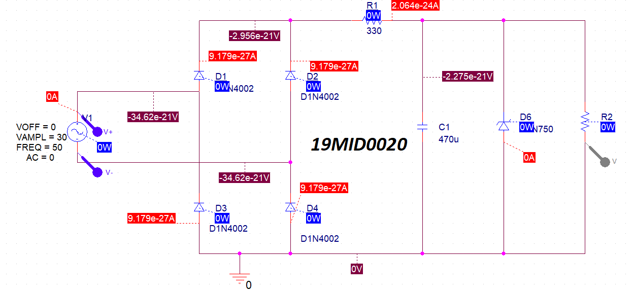

**Output graph:**

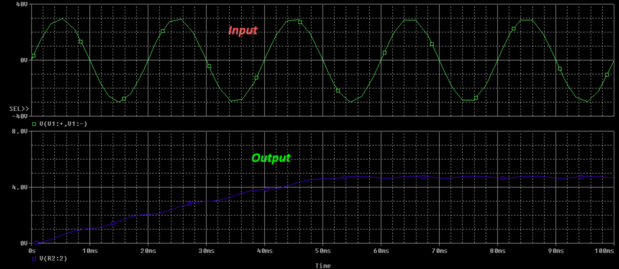

**Procedure:**

1) Design the circuit with the following Voltage specifications (Vsin)

i) VOFF=0

ii) VAMPL=30

iii) FREQ=50

iv) AC=0

2)Create simulation profile of type “Time Domain” with run time 500ms.

3)Move the ground to the line which is below the bottom diodes and use only the voltage marker and not differential at the output.

4) Use differential markers only at the input.

**Result:**

The simulation of regulated power supply circuit with AC input is designed and performed using OrCAD Pspice software.

**Inference:**

* The rectified output of AC wave is not the complete DC output. It is just the partial output in which the current is made unidirectional.
* The designed circuit makes the oscillating rectified AC voltage to a fairly constant DC voltage.

­

**Reg. No: 19MID0020 Name: Prashanth.S Date: 09/10/2020**